TITLE (LIMIT THE TITLE TO A MAXIMUM OF 17 WORDS)
First author^{1*} Second author¹ Third author²
Fourth author³ Fifth author² Sixth author¹
¹ Department of Computer Science, University, Country
² International Laboratories, City, Country
³ Company, Address

ABSTRACT*
The abstract should be placed below the title, list of Authors and affiliations. It should contain a maximum of 200 words.
Keywords: insert here from 3 to 5 keywords separated by a comma (no bold, no capitalized letters, italic). Note that the keywords insertion is mandatory.
- INTRODUCTION
This template includes all the information about format- ting manuscripts for the Forum Acusticum 2023 Conference. Please follow these guidelines carefully to give the final proceedings a uniform look. Most of the required formatting is achieved automatically by using the supplied style file (LATEX) or template (Word). If you have any questions, please contact the Conference Secretary (info@fa2023.org). This template can be downloaded from the FA2023 web site.
- PAPER LENGTH AND File Size
The authors can submit for the EAA FA2023 Conference either a short paper from 2 to 4 pages or a long paper of maximum 8 pages, all written in English, and not previously published. Each length indicated is intended as overall and includes figures, tables, references and acknowledgments.
Papers should be submitted as PDF files. The file size should not exceed 25 MB. To avoid erroneous layout changes, please save the documents’ drafts in .doc (i.e., not in .docx) and then in the final PDF version. Please compress images and figures as necessary before submitting.
- PAGE size and template formatting
The proceedings will be formatted for A4-size paper (21.0 cm x 29.7 cm), portrait layout. All material on each page should fit within a rectangle of 17.0 cm x 20.7 cm, centered on the page, beginning 5.0 cm from the top of the page and ending with 4.0 cm from the bottom. The left and right margins should be 2.0 cm. The text should be in two 8.1 cm columns with a 0.8 cm gutter. All text must be in a two-column format. Text must be fully justified. All papers must be compliant with the formatting guidelines provided in this template for papers indexing purposes and timely reviews. Any paper that varies from this format will be returned to the author(s) for re-formatting using the presented guidance. Only papers conforming to the template guidelines will be included in the proceedings.
- Typeset Text
  - Normal or body text
Please use a 10pt (point) Times New Roman font with single line spacing and 0.2pt characters spacing (i.e., condensed spacing by 0.2pt).
  - Title and authors
The following is for making a camera-ready version. The title is 15pt Times New Roman, bold, caps, upper case, centered, with 16pt space before, 26pt space after it and with characters spacing of 0.2pt. Authors’ names are centered. The lead author’s name is to be listed first (left-most), and the co-authors’ names after. If the addresses for all authors are the same, include the address only once. If the authors have different addresses, put the addresses as multiple affiliations.
  - First page copyright notice
Please include the copyright notice exactly as it appears here in the lower left-hand corner of the page. Make sure to update the first author’s name in the copyright notice, accordingly. It is set in 9pt Times New Roman.
  - Page numbering, headers and footers
Do not modify headers, footers or page numbers in your submission. These will be added electronically at a later stage, when the publications are assembled.
    - First level headings
First level headings are in Times New Roman 10pt bold and capital, centered, with 16pt space before, 8pt space after it and with characters spacing of 0.2pt.
    - Second level headings
Second level headings are in Times New Roman 10pt bold, flush left, with 10pt space before, 6pt space after it and with characters spacing of 0.2pt.
    - Third level headings
Third level headings are in Times New Roman 10pt italic, flush left, with 7pt space before, 8pt space after it and with characters spacing of 0.2pt.
Using more than three levels of headings is highly discouraged.
- Footnotes and Figures
  - Normal or body text
Indicate footnotes with a number in the text. Use 9pt type for footnotes. Place the footnotes at the bottom of the page on which they appear.
  - Figures, tables, and captions
All artworks must be centered, neat, clean, and legible. All lines should be very dark for purposes of reproduction and artworks should not be hand-drawn. Proceedings will only be supplied in electronic form, so color figures are acceptable. However, for sustainability reasons it is suggested to make artworks (figures and graphs) comprehensible and clear also for black and white print. In this case a best effort should be made to remove all references to colors in figures in the text. Please ensure sufficient resolution to avoid pixelation and compression effects. Captions for figures and tables appear below and above the object, respectively. Each figure or table is numbered consecutively and is introduced in the text before appearing on the page. Captions should be Times New Roman 11pt, with 10pt space before, 6pt space after it and with characters spacing of 0.2pt. Place tables/figures in text as close to the reference as possible. References to tables and figures should be capitalized, for example: see Fig. 1 and Tab. 1. Figures and tables may extend on a single column to a maximum width of 8.1 cm and across both columns to a maximum width of 17.0 cm.

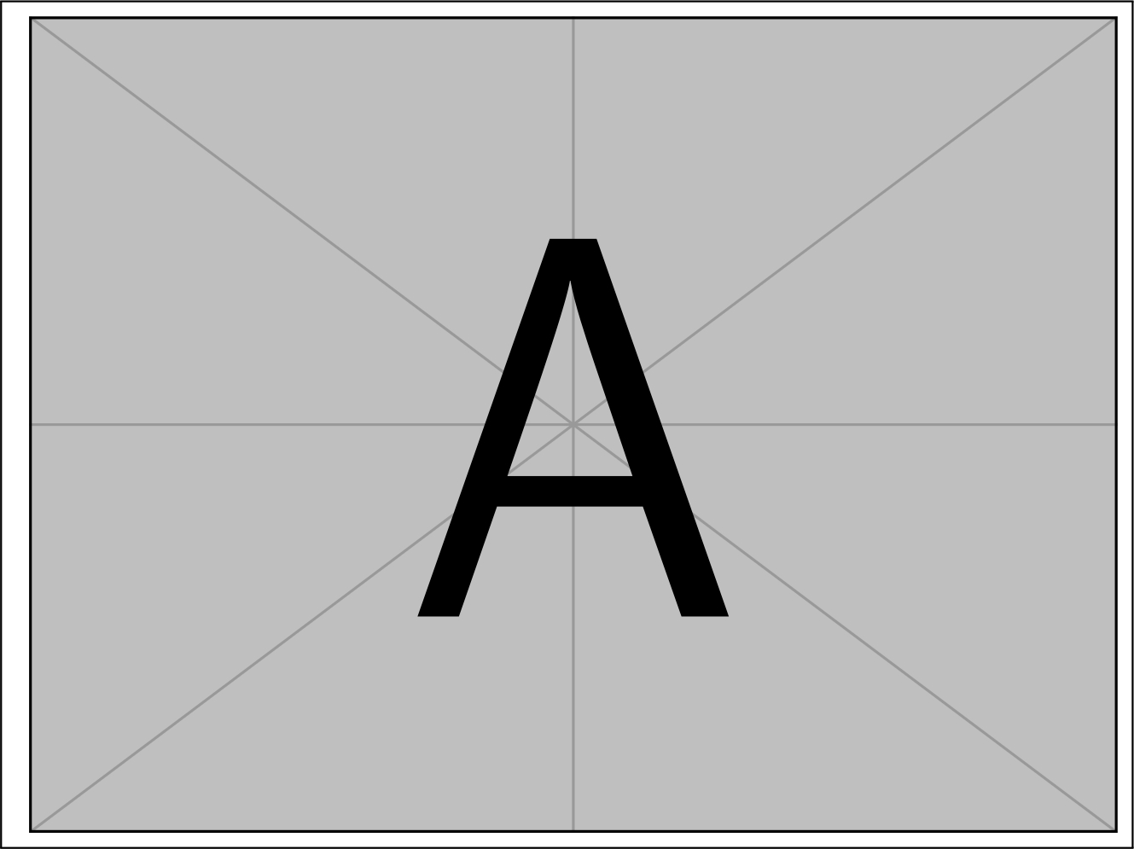
Figure 1. Figure captions should be placed below the figure.

Table 1. Table captions should be placed above the table.
String value | Numeric value
Value 1 | 2023
- Equations
Equations should not appear in the main body of the text, should be placed on separate lines and should be numbered. The number should be on the right side, in parentheses, as in Eqn. (1).

$E={\text{mc}}^{2}$ (1)
- Citations
All bibliographical references should be listed at the end, inside a section named “REFERENCES,” numbered and in order of appearance. All references listed should be cited in the text. When referring to a document, type the number in square brackets [1], or for a range [1-3].
Standard abbreviations should be used in your bibliography. When the following words appear in the references, please abbreviate them:

- Proceedings → Proc.
- Record → Rec.
- Symposium → Symp.
- Technical Digest → Tech. Dig.
- Technical Paper → Tech. Paper
- First → 1st
- Second → 2nd
- Third → 3rd
- Fourth/nth → 4^{th/nth}.
- INSPECTING THE PDF FILE
Carefully inspect the PDF file before submission to be sure that the PDF conversion was done properly and that there are no error messages when you open the PDF file. Common problems are: missing or incorrectly converted symbols especially mathematical symbols, failure of figures to reproduce, and incomplete legends in figures. Identification and correction of these problems is the responsibility of the authors.
- ACKNOWLEDGMENTS
In this section, you can acknowledge any support given which is not covered by the author contribution or funding sections. This may include administrative and technical support, or donations in kind (e.g., materials used for experiments).
- REFERENCES
- C. Author, “The title of the conference paper,” in Proc. of the International Symposium on Topic, (Chania, Greece), pp. 000–111, 2000.
- A. Someone, B. Someone, and C. Someone: “The title of the journal paper,” Journal of Name, vol. A, no. B, pp. 111–222, 2010.
- X. Someone and Y. Someone: Title of the Book. City: Editorial Acme, 2012.

*Corresponding author: first.author@email.ad. Copyright: ©2023 First author et al. This is an open-access article distributed under the terms of the Creative Commons Attribution 3.0 Unported License, which permits unrestricted use, distribution, and reproduction in any medium, provided the original author and source are credited.
This is a footnote.

